Tableau curso

<https://public.tableau.com/app/profile/lukas.halim/viz/Profitbyregion/Sheet1>

<https://learningtableau.com/data-analyst-study-guide/>

<https://help.tableau.com/current/pro/desktop/en-us/datafields_typesandroles.htm>

<https://help.tableau.com/current/pro/desktop/en-us/datafields_typesandroles.htm#how-continuous-and-discrete-fields-change-the-view>

<https://help.tableau.com/current/pro/desktop/en-us/datasource_datamodel_whatschanged.htm#using-a-tables-count-field-instead-of-number-of-records>

<https://help.tableau.com/current/pro/desktop/en-us/datafields_understanddatawindow_meavalues.htm>

<https://public.tableau.com/app/profile/lukas.halim/viz/BulletGraph_15958744910310/BulletGraph>

<https://public.tableau.com/app/profile/lukas.halim/viz/BulletGraphandBarinBar/Dashboard1>

<https://public.tableau.com/app/profile/lukas.halim/viz/BoxPlotSolution/Sheet2>

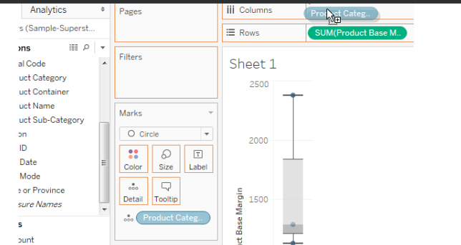

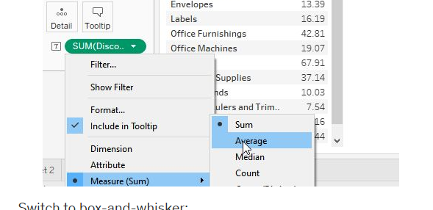

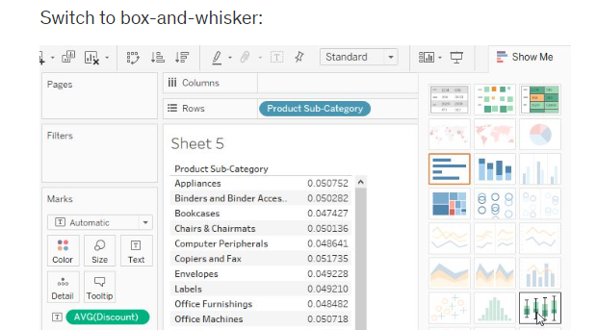

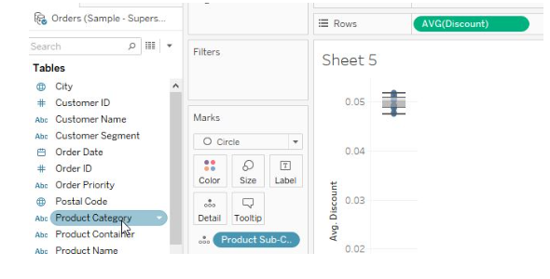

<https://public.tableau.com/app/profile/lukas.halim/vizzes>

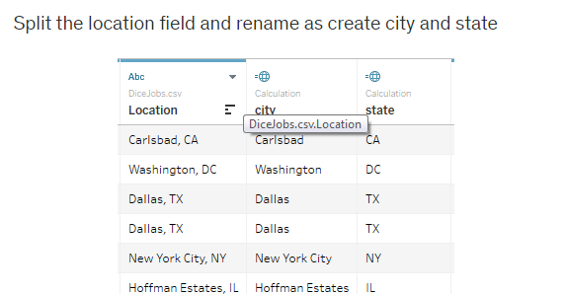

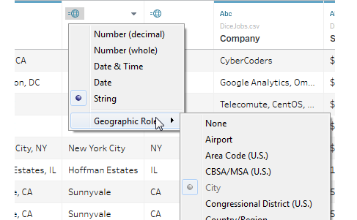

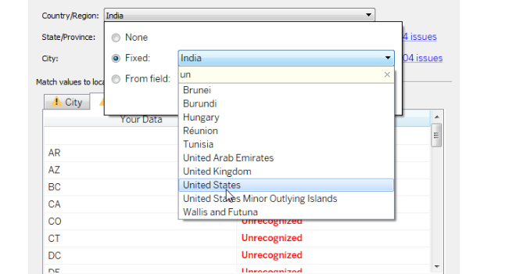

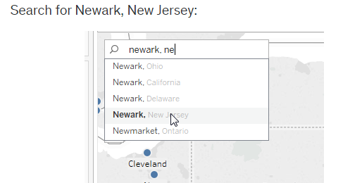

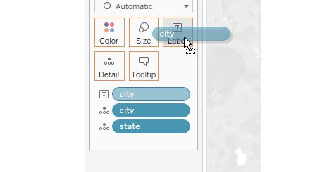

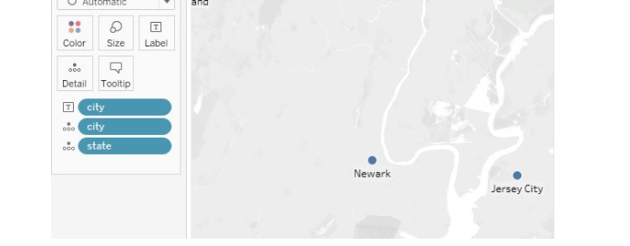

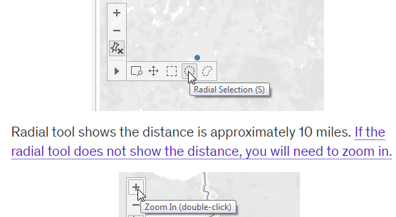

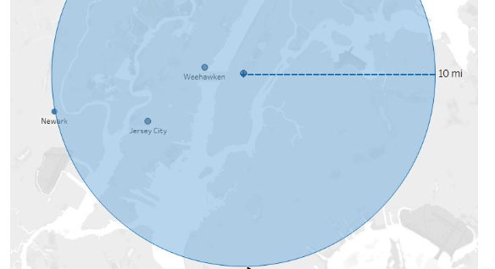

<https://public.tableau.com/app/profile/lukas.halim/viz/backgroundmapexample/Sheet1>

<https://public.tableau.com/app/profile/lukas.halim/viz/LondonPopDen/Sheet1>

<https://data.london.gov.uk/dataset/statistical-gis-boundary-files-london>

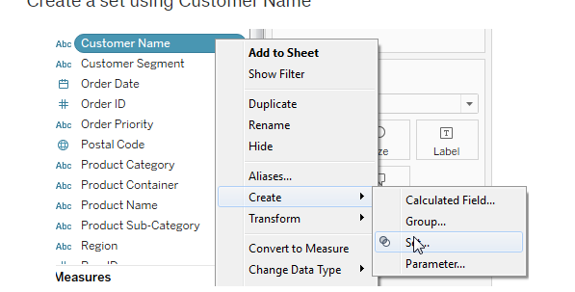

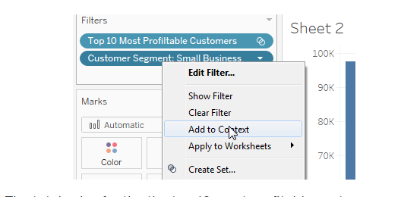

<https://public.tableau.com/app/profile/lukas.halim/viz/ProfittoSales_15690140433160/ProfittoSales>

<https://public.tableau.com/app/profile/lukas.halim/viz/TimetoShip_0/TimetoShip>

<https://public.tableau.com/app/profile/lukas.halim/viz/IfStatements/IfStatements>

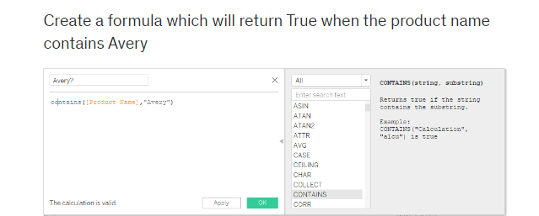

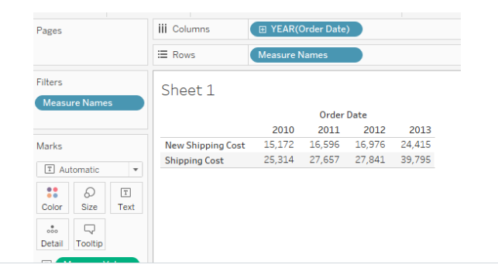

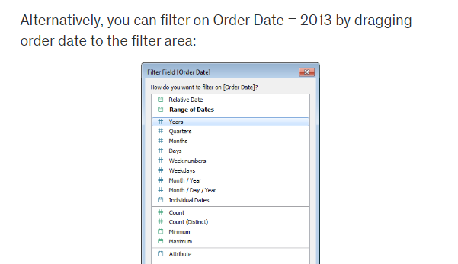

<https://public.tableau.com/app/profile/lukas.halim/viz/OrderFrequencyProfitableDays/ProfitableDays>

<https://public.tableau.com/app/profile/lukas.halim/viz/LODPercentofTotalSales/PercentofTotal>

<https://public.tableau.com/app/profile/lukas.halim/viz/ExcludeLODExample/ComparativeSalesAnalysis>

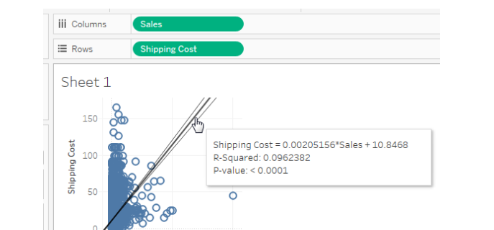

<https://public.tableau.com/app/profile/lukas.halim/viz/SimpleTrendline/Trendline>

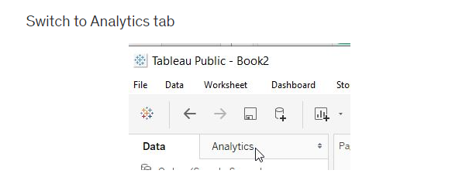

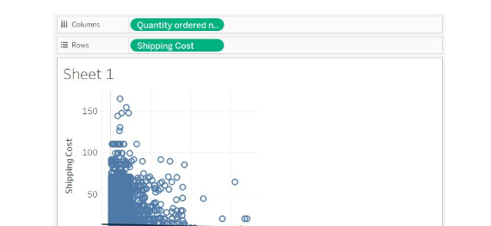

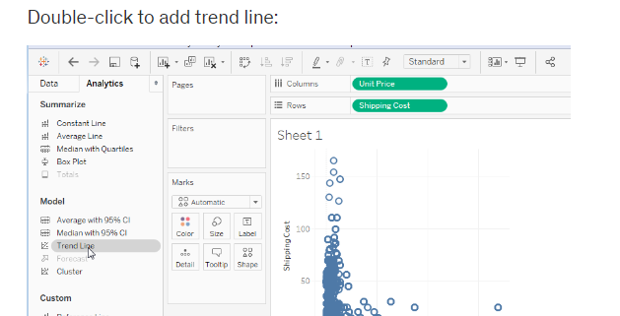

<https://public.tableau.com/app/profile/lukas.halim/viz/ForecastLaborParticipation/Sheet1>

<https://learningtableau.com/quiz/data-analyst-practice-exam-1/>

pass: Paper4

<https://learningtableau.com/quiz/data-analyst-practice-exam-2/>

pass: Wash5

<https://public.tableau.com/app/profile/lukas.halim/viz/PrepQuiz2/Question1>

<https://public.tableau.com/app/profile/lukas.halim/viz/PrepQuiz3/Q3>

[www.dropbox.com/s/ix2jl6epsikredv/LOD%20Quiz%20Answers.pdf?dl=1](http://www.dropbox.com/s/ix2jl6epsikredv/LOD%20Quiz%20Answers.pdf?dl=1)

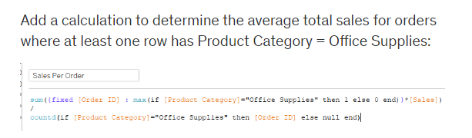

[**http://learningtableau.com/quiz/tableau-10-practice-exam/**](http://learningtableau.com/quiz/tableau-10-practice-exam/)

**Bebop5**

[**https://learningtableau.com/quiz/tableau-10-practice-exam-2/**](https://learningtableau.com/quiz/tableau-10-practice-exam-2/)

**Rose7**

[**https://learningtableau.com/quiz/tableau-certified-associate-practice-exam-3/**](https://learningtableau.com/quiz/tableau-certified-associate-practice-exam-3/)

**Howdy3**